TechnicalDocument _Lab4
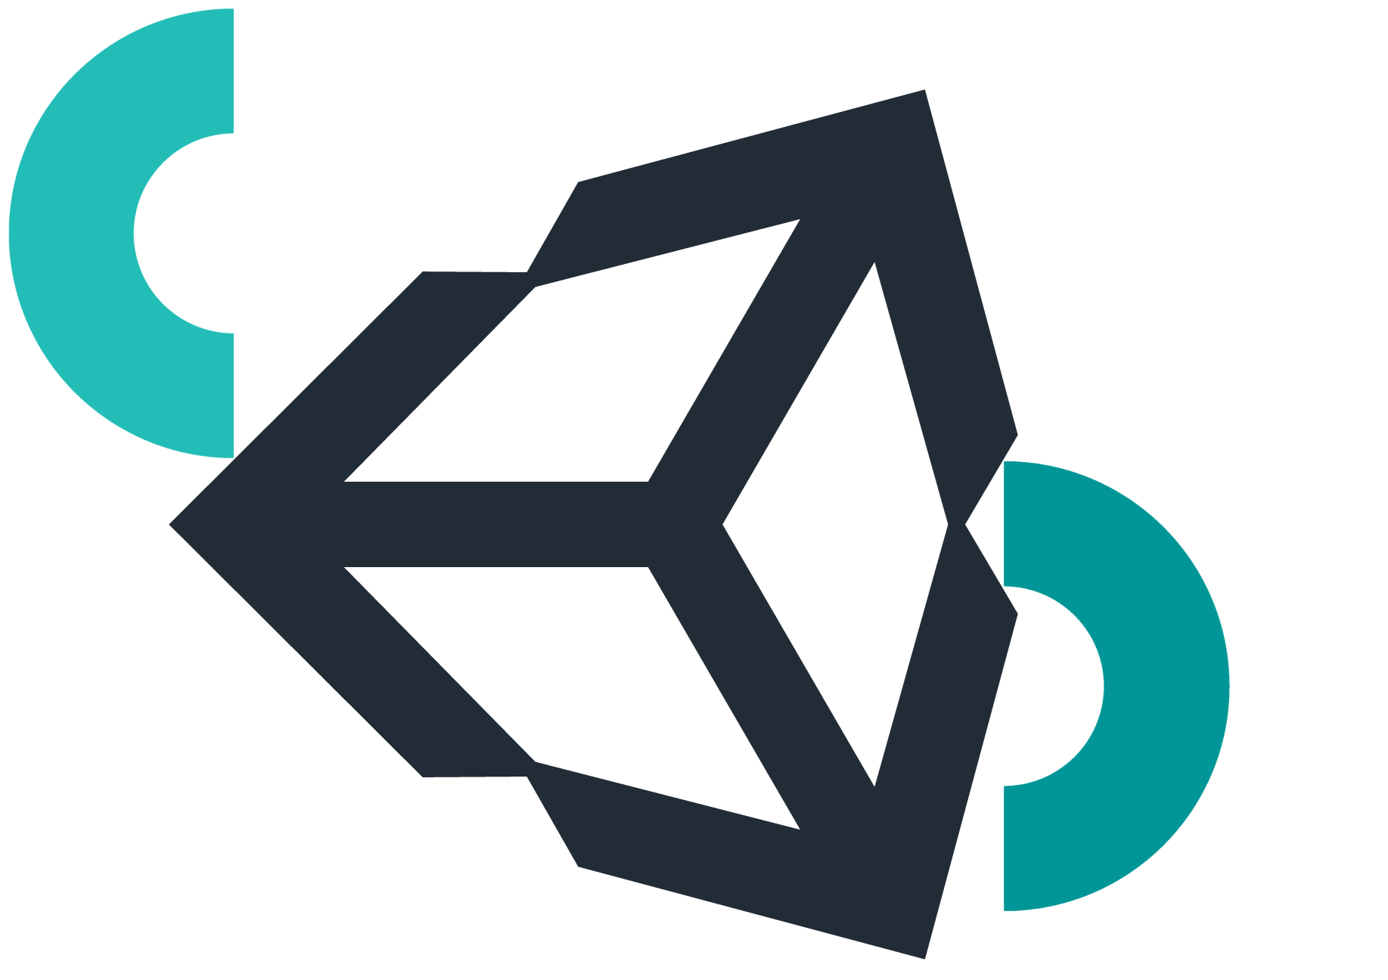

Name:
Jorge Trindade number: 2026160671
Ricardo Alvito number: 2026133520

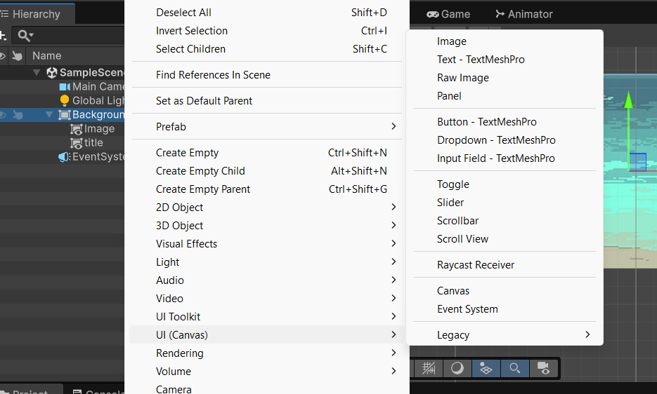
Level 1
In the image, we can see how we create the Canvas and the image inside the Canvas. We can also see that an EventSystem is automatically created together with the Canvas.

We rename the Canvas to "Background" because it and the image will be used as the background.
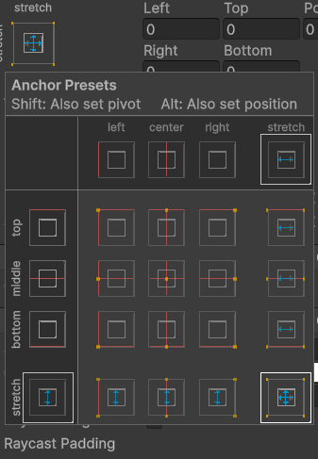

In this image, we can see the Anchor Presets. They allow us to define how the image will appear in the game's background. Since a white square is selected, we chose the option that makes the image expand in all directions, placing the complete image in the center of the screen and making it fill the entire game screen.

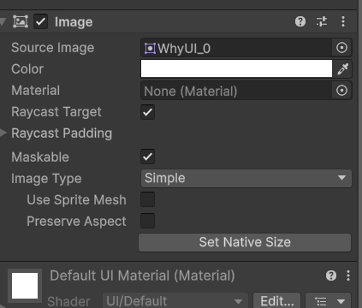
In this image, we can see that we assigned our chosen background image to the Source Image field of the Image component inside "Background". This makes the background display the image we selected instead of remaining white.
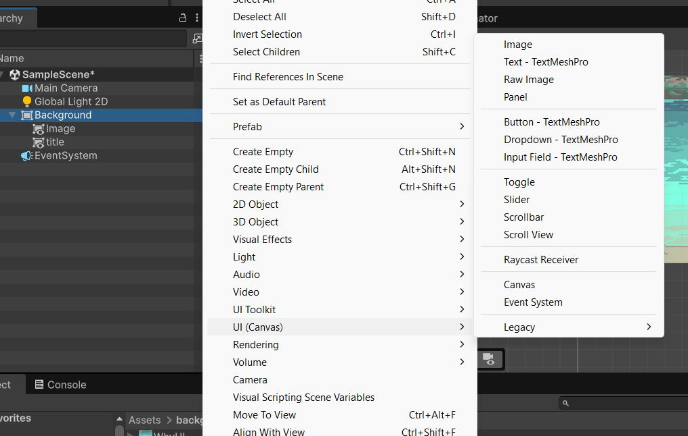
In this image, we can see that we also added a Text - TextMeshPro component to "Background", called "Title", to display the name.
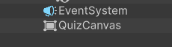
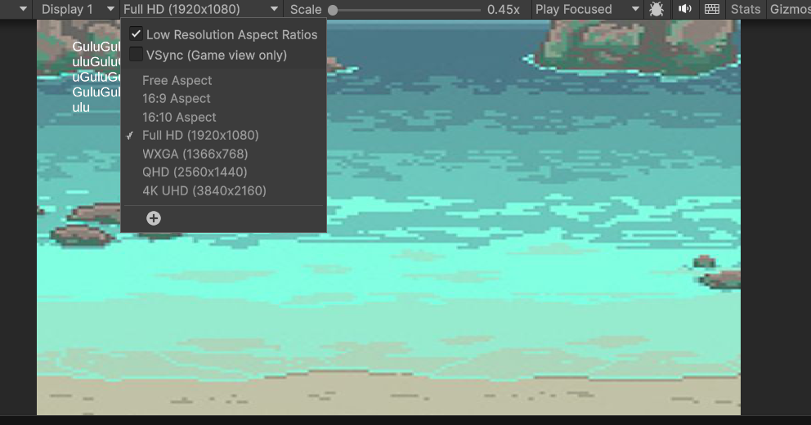
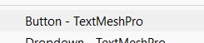
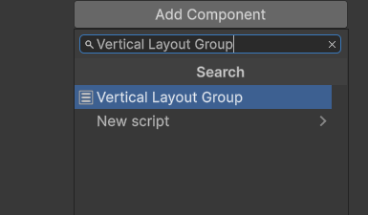
In these images, we changed the game's resolution settings, added another Canvas called "QuizCanvas", added a Button - TextMeshPro, and created a GameObject to hold the answer buttons. We added a Vertical Layout Group component to the GameObject so that the buttons are automatically arranged vertically.

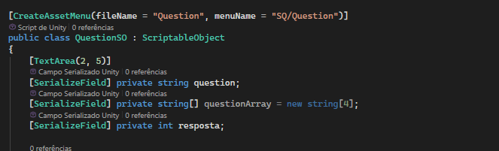
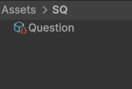
Level 2
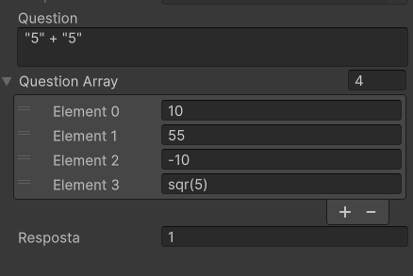
In these images, we can see the creation of a ScriptableObject to make it easier to create questions. With it, we can manage the question Question, the answers Question Array, and the correct answer Answer.

Level 3

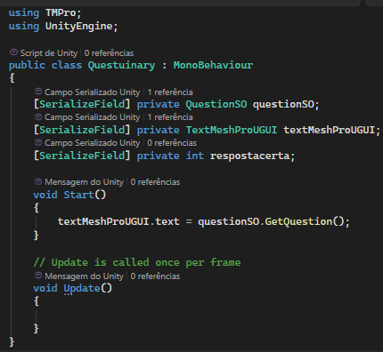  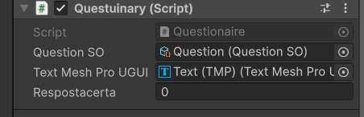 | In this code, we create the Questionary script. In it, we create three variables that store the QuestionSO, the text we will use to display the question, and the number of the correct answer.  In the Start method, we get the question text and place it in the text field so that the player knows what is being asked.

Level 4
Questuinary

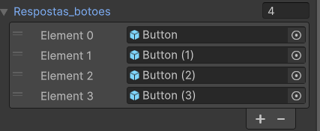  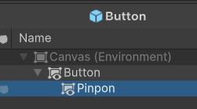  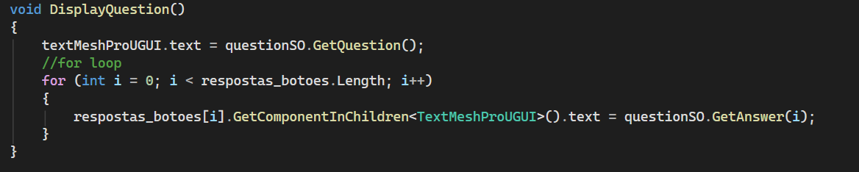 | In Questionary, we added an array of GameObjects (later changed to Button because it is better). It stores references to the buttons in our Quiz Canvas. This allows us to use a for loop to assign the possible answers to the buttons. We then moved this code into the DisplayQuestion() method to make the code more organized.

Questuinary
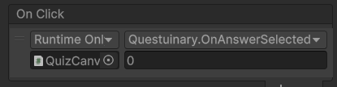
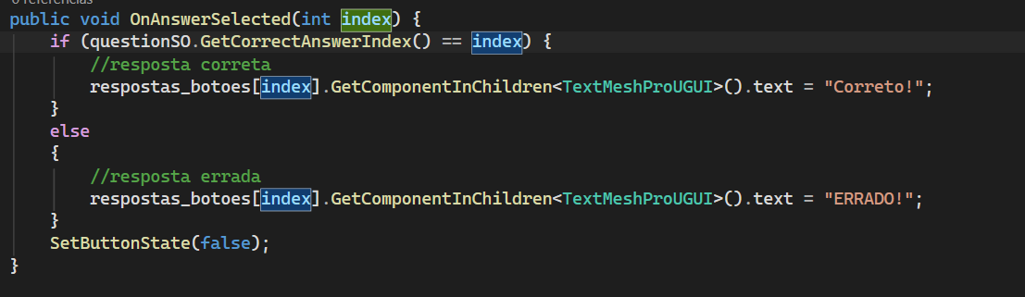
In this code, we connect the button to the OnAnswerSelected method and check whether its value matches the index of the correct answer.

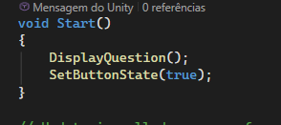
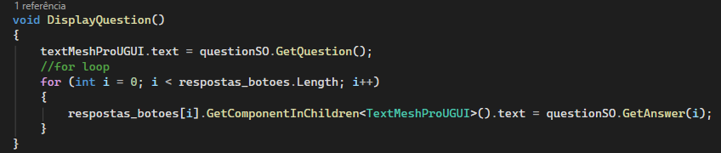
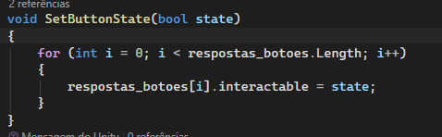
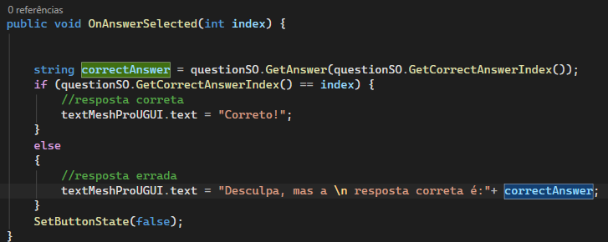
In this code, we create the OnAnswerSelected() method and connect it to the OnClick event of the buttons.

Inside this method, we get the correct answer and check whether the index returned by the button matches the index of the correct answer. If they match, we change the question text to "Correct!". If they do not match, we change the text to say that the answer is wrong and show the correct answer.

After that, we call SetButtonState() to disable all the buttons.

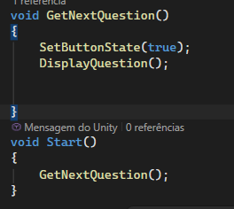
Level 5
Now we create a new method that allows us to change the question.

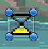
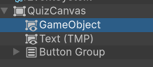
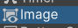
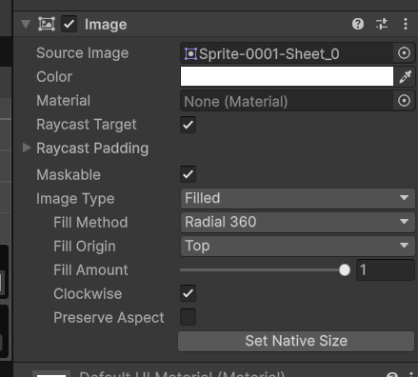

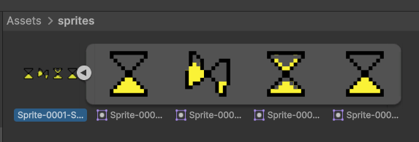

In this part, we create a GameObject to hold a loading bar. This allows us to animate it and provide a visual indication that the player needs to wait.

Criação do script “Timer”
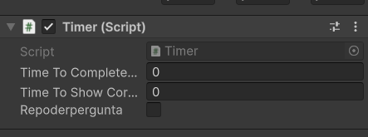
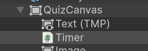
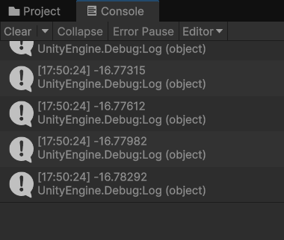
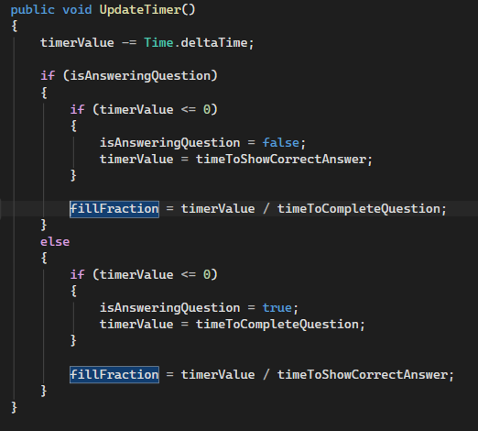
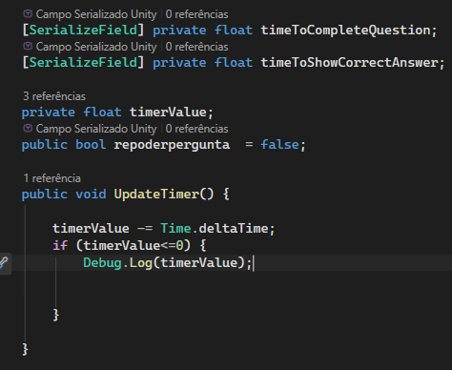
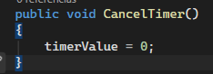
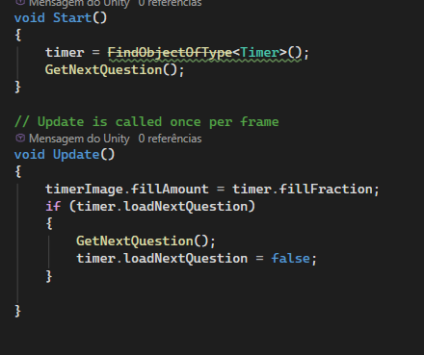

In the code, we can see that when a question ends, a timer is started. It waits for a short time before loading the next question, allowing the player to select answers again.
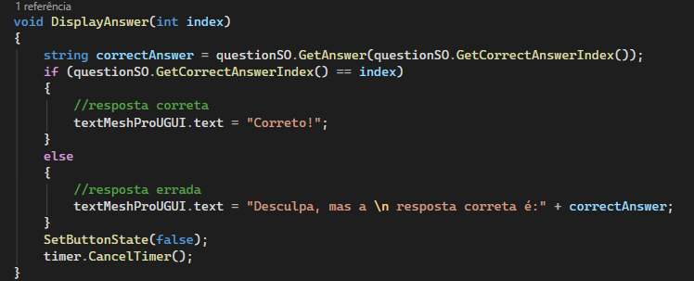

In this code, we create the DisplayAnswer function, which receives the index of the button clicked by the player.

Inside it, we get the correct answer stored in QuestionSO and check whether the clicked index matches the index of the correct answer.

If they match, we change the question text to "Correct!". If they do not match, we change the text to say that the answer is wrong and show the correct answer.

After that, we call SetButtonState(false) to disable all the buttons and timer.CancelTimer() to stop the timer, ending the question.
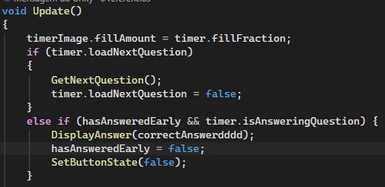
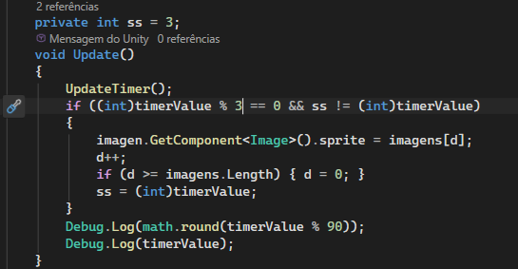

In these images, we can see the continuation of the code, focusing on how the timer works and how the next question is loaded automatically.
In the first code, inside the Update method, we update the timer's loading bar (fillAmount) according to the remaining time. Then, we check whether the time has run out (loadNextQuestion). If it has, we call the GetNextQuestion() function to load the next question and reset the variable.
Otherwise, we check whether the player has already answered before the time runs out (hasAnsweredEarly). If so, we call the DisplayAnswer function to show the result and disable the buttons.
In the second code, we create the timer animation. We define a variable to store the current second and, in the Update method, call the UpdateTimer() function to update the timer.
Next, we check whether the current second is a multiple of 3 (using % 3) and whether it is different from the last stored second. If both conditions are met, we change the image in the component to create the animation and update the control variable.
Finally, the code also displays some timer values in the console using Debug.Log so that we can follow how it works.

